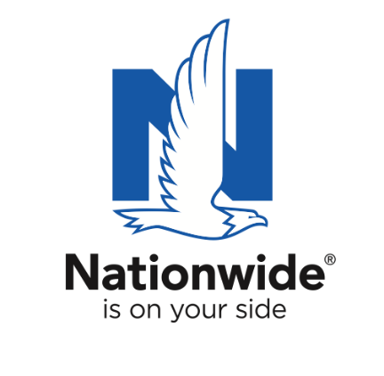
FOR IMMEDIATE RELEASE

April 7, 2025
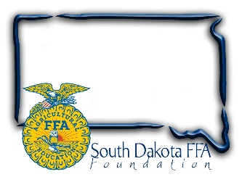
Contact:
Gerri Ann Eide
gerri@sdffafoundation.org
605-765-4865

SD Teacher Named “Ag Educator of the Year”

Willow Lake’s Dan Tonak honored as South Dakota’s Golden Owl Award®
2024-2025 grand prize winner

Brookings, SD – As the need grows for more ag educators across the nation, the ag teachers who go above and beyond in educating America’s youth and future leaders are more important than ever. In South Dakota, eight exceptional ag teachers were recently named as finalists of the 2024-2025 Golden Owl Award® for their positive impact in the classroom and communities they serve. Of the finalists, Dan Tonak, an agricultural teacher at Willow Lake, was named South Dakota’s grand prize winner and 2024-2025 Ag Educator of the Year.

Nationwide, in partnership with the South Dakota FFA Foundation recognized Tonak as the Golden Owl Award grand prize winner during the South Dakota FFA State Convention. In addition to the title of South Dakota Ag Educator of the Year, Tonak will receive the coveted Golden Owl Award trophy and a $3,000 Nationwide-funded donation to further Willow Lakes’s agricultural education efforts.

In his nomination, one of Mr. Tonak’s students shared, “He is the heart and soul of our FFA chapter and agricultural education program, genuinely caring about us, encouraging us to push our boundaries, compete at higher levels, and represent our community with pride, which has been instrumental in our personal growth. Always the first one to arrive and the last to leave, sacrificing personal time—whether it’s early mornings, late evenings, or weekends—to make sure we have the knowledge, skills, and confidence to excel in every challenge that comes our way. In class we get top-notch materials and creative lessons, ensuring we’re well-prepared - whether it’s guiding hands-on projects, encouraging us to participate in competitions, or helping us set career goals, Our ag teacher is a mentor and inspiring role model, always there to lend a hand or offer valuable advice. The passion for agriculture makes me and my peers see the true value in hard work, teamwork, and strong leadership.The impact on today’s youth goes far beyond traditional classroom learning by inspiring us to become leaders, problem-solvers, and critical thinkers. It’s clear to me that their commitment to agricultural education is unparalleled; Not just teaching about agriculture, imparting lifelong lessons about responsibility, character, and leadership, with influence extending into our communities, as students carry lessons learned in the ag class into various careers in agriculture and beyond.
.”

Reflecting on his classroom leadership, Tonak shared, ““My career is defined by doing the very best I can each day to educate students with knowledge about agriculture, instill in them the importance of responsibility, and inspire them to do their best in all things. Two principles I’ve held myself to during my career are to teach the importance of responsibility and that hard work can pay off with accomplishments that far exceed what a student may think they are capable of.”

Nationwide established the Golden Owl Award with its state partners to shed light on the contributions of South Dakota’s leading agricultural teachers and provide additional resources to support their programs.

“Nationwide is proud to recognize the dedicated teachers who are educating and inspiring students to pursue careers in agriculture,” said Brad Liggett, president of Agribusiness at Nationwide. “We’re honored to have the opportunity to appreciate their contributions, highlight the growing need for their services, and supply additional resources to help provide their students with optimal learning experiences.”

Nationwide supports the future of the ag community through meaningful sponsorships of national and local organizations. In conjunction with the Golden Owl Award, Nationwide is donating $5,000 to each participating state’s FFA, including the South Dakota’s to further support the personal and professional growth of students, teachers and advisors alike.

For more information, visit www.goldenowlaward.com.

About SD FFA
The SD FFA has 6500 members in 112 high school agriculture education programs. The SD FFA Foundation is proud to support Agricultural Education and the FFA's mission to make a difference in the lives of students by developing their potential for premier leadership, personal growth and career success through agricultural education. For more information about the South Dakota FFA Foundation and South Dakota's FFA programs, visit www.sdffafoundation.org or follow us on Facebook.
About Nationwide
Nationwide, a Fortune 100 company based in Columbus, Ohio, is one of the largest and strongest diversified insurance and financial services organizations in the United States. Nationwide is rated A+ by Standard & Poor’s. An industry leader in driving customer-focused innovation, Nationwide provides a full range of insurance and financial services products including auto, business, homeowners, farm and life insurance; public and private sector retirement plans, annuities and mutual funds; excess & surplus, specialty and surety; and pet, motorcycle and boat insurance.

For more information, visit www.nationwide.com.

Subscribe today to receive the latest news from Nationwide and follow Nationwide PR on X.
Nationwide, Nationwide is on your side and the Nationwide N and Eagle are service marks of Nationwide Mutual Insurance Company. © 2025

